**AIM: Rubrics Task Details:**

Create a Laravel based web application that manages the products, display all products brief

information on the home page and show only “more details” option to the logged in users for

each product. The “more details” option should display detailed information about the

product only for logged in users. You also need to provide options to register a new user as

well as add, update and delete any products. (You can have your own database)

**Rubrics Task Submission (Upload Word or PDF File to Google Classroom):**

1. Provide the complete data dictionary (the table layouts of the database).

2. Provide the screenshot of each GUI.

3. Provide the complete code of the application. The code should include all Models,

Controllers and Views created in the application

4. Provide the code of all the supporting code files created in the application.

**Register.php (Model)**

<?php

namespace App\Models;

use Illuminate\Database\Eloquent\Factories\HasFactory;

use Illuminate\Database\Eloquent\Model;

class Register extends Model

{

use HasFactory;

protected $fillable = [

'name', 'email','mobile','city','age'

];

}

**Web.php (Route)**

<?php

use Illuminate\Support\Facades\Route;

use App\Http\Controllers\RegisterController;

Route::get('/', function () {

return view('welcome');

});

Route::resource('registers', RegisterController::class);

**RegisterController.php (Controller)**

<?php

namespace App\Http\Controllers;

use App\Models\Register;

use Illuminate\Http\Request;

class RegisterController extends Controller

{

/**

* Display a listing of the resource.

*

* @return \Illuminate\Http\Response

*/

public function index()

{

$registers = Register::all();

return view('registers.index',compact('registers'));

}

/**

* Show the form for creating a new resource.

*

* @return \Illuminate\Http\Response

*/

public function create()

{

return view('registers.create');

}

/**

* Store a newly created resource in storage.

*

* @param \Illuminate\Http\Request $request

* @return \Illuminate\Http\Response

*/

public function store(Request $request)

{

$request->validate([

'name' => 'required',

'email' => 'required|email',

'mobile' => 'required|numeric',

'city' => 'required',

'age' => 'required|numeric'

]);

Register::create($request->all());

return redirect()->route('registers.index')

->with('success', 'User Registration Successful...');

}

/**

* Display the specified resource.

*

* @param \App\Models\Register $register

* @return \Illuminate\Http\Response

*/

public function show(Register $register)

{

return view('registers.show', compact('register'));

}

/**

* Show the form for editing the specified resource.

*

* @param \App\Models\Register $register

* @return \Illuminate\Http\Response

*/

public function edit(Register $register)

{

return view('registers.edit', compact('register'));

}

/**

* Update the specified resource in storage.

*

* @param \Illuminate\Http\Request $request

* @param \App\Models\Register $register

* @return \Illuminate\Http\Response

*/

public function update(Request $request, Register $register)

{

$request->validate([

'name' => 'required',

'email' => 'required|email',

'mobile' => 'required|numeric',

'city' => 'required',

'age' => 'required|numeric'

]);

$register->update($request->all());

return redirect()->route('registers.index')

->with('success', 'Details of User Updated Successfully');

}

/**

* Remove the specified resource from storage.

*

* @param \App\Models\Register $register

* @return \Illuminate\Http\Response

*/

public function destroy(Register $register)

{

$register->delete();

return redirect()->route('registers.index')

->with('success', 'User Account Deleted !...');

}

}

**Register Table (Migrations)**

<?php

use Illuminate\Database\Migrations\Migration;

use Illuminate\Database\Schema\Blueprint;

use Illuminate\Support\Facades\Schema;

class CreateRegistersTable extends Migration

{

/**

* Run the migrations.

*

* @return void

*/

public function up()

{

Schema::create('registers', function (Blueprint $table) {

$table->increments('id');

$table->string('name', 255)->nullable();

$table->string('email', 255)->nullable();

$table->string('mobile', 255)->nullable();

$table->string('city', 500)->nullable();

$table->string('age', 3)->nullable();

$table->timestamps();

});

}

/**

* Reverse the migrations.

*

* @return void

*/

public function down()

{

Schema::dropIfExists('registers');

}

}

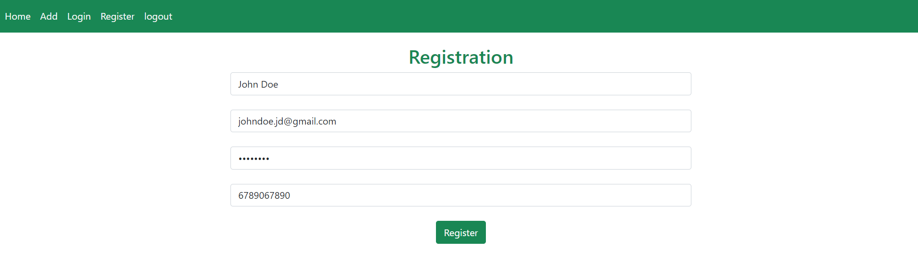

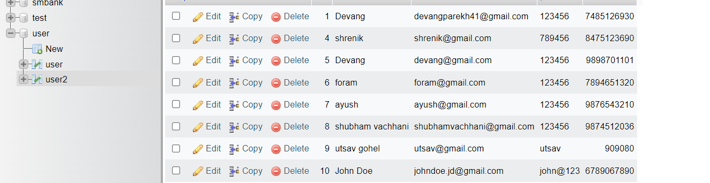

**Welcome.blade.php (View)**

<!DOCTYPE html>

<html lang="{{ str_replace('_', '-', app()->getLocale()) }}">

<head>

<title>Laravel 8 CRUD Operations</title>

<link rel="stylesheet" href="https://stackpath.bootstrapcdn.com/bootstrap/4.3.1/css/bootstrap.min.css" integrity="sha384-ggOyR0iXCbMQv3Xipma34MD+dH/1fQ784/j6cY/iJTQUOhcWr7x9JvoRxT2MZw1T" crossorigin="anonymous">

</head>

<body>

<h1>Welcome to the demo of Laravel 8 CRUD Operations...</h1>

<br><br>

<h2>To See Demo... <a class="btn btn-success" href="{{ route('registers.index') }}"> Click Here</a></h2>

</body>

</html>

**Layout.blade.php(View)**

<!DOCTYPE html>

<html>

<head>

<title>Laravel CRUD Tutorials </title>

<link rel="stylesheet" href="https://stackpath.bootstrapcdn.com/bootstrap/4.3.1/css/bootstrap.min.css" integrity="sha384-ggOyR0iXCbMQv3Xipma34MD+dH/1fQ784/j6cY/iJTQUOhcWr7x9JvoRxT2MZw1T" crossorigin="anonymous">

</head>

<body>

<div class="jumbotron text-center">

<h1>Laravel 8 CRUD Operations </h1>

<p>Demo By: Rachit Adhvaryu</p>

</div>

<div class="container">

@yield('content')

</div>

<br><br>

<div class="jumbotron text-center" style="margin-bottom:0">

<p>It is very easy to work in Laravel due to its high resources and flexibility...</p>

</div>

</body>

</html>

**Index.blade.php (View)**

@extends('registers.layout')

@section('content')

<div class="row">

<div class="col-lg-12 margin-tb">

<div class="pull-left">

<h2>All Registered Users</h3>

</div>

<br>

<div class="pull-right">

<a class="btn btn-primary" href="{{ route('registers.create') }}"> New Registration..!.. Here</a><br>

</div>

</div>

</div>

<br><br>

@if ($message = Session::get('success'))

<div class="alert alert-success">

<p>{{ $message }}</p>

</div>

@endif

<br><br>

<table class="table table-bordered table-hover">

<thead class="thead-dark">

<tr>

<th>Sr.No.</th>

<th>Name</th>

<th>Email</th>

<th>Mobile</th>

<th>City</th>

<th>Age</th>

<th width="300px">Action</th>

</tr>

</thead>

<?php $i=0; ?>

@foreach ($registers as $register)

<tr>

<td>{{ ++$i }}</td>

<td>{{ $register->name }}</td>

<td>{{ $register->email }}</td>

<td>{{ $register->mobile }}</td>

<td>{{ $register->city }}</td>

<td>{{ $register->age }}</td>

<td>

<form action="{{ route('registers.destroy',$register->id) }}" method="POST">

<a class="btn btn-info" href="{{ route('registers.show',$register->id) }}">View</a>

<a class="btn btn-success" href="{{ route('registers.edit',$register->id) }}">Update</a>

@csrf

@method('DELETE')

<button type="submit" class="btn btn-danger">Remove</button>

</form>

</td>

</tr>

@endforeach

</table>

@endsection

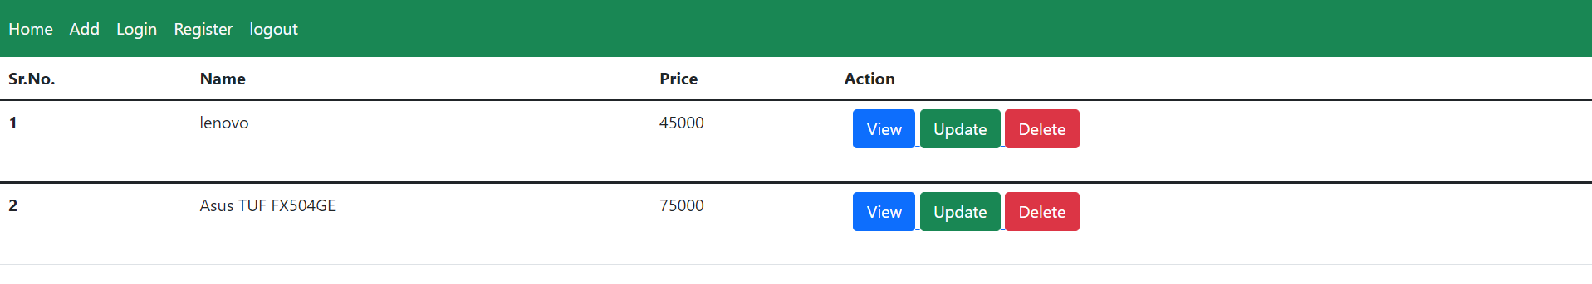

**Edit.blade.php (View)**

@extends('registers.layout')

@section('content')

<div class="row">

<div class="col-lg-12 margin-tb">

<div class="pull-left">

<h2>Edit User Details</h2>

</div>

<br>

<div class="pull-right">

<a class="btn btn-primary" href="{{ route('registers.index') }}">Go Back</a>

</div>

</div>

</div>

<br><br>

@if ($errors->any())

<div class="alert alert-danger">

<strong>Warning!</strong> Invalid Inputs...<br><br>

<ul>

@foreach ($errors->all() as $error)

<li>{{ $error }}</li>

@endforeach

</ul>

</div>

@endif

<br><br>

<form action="{{ route('registers.update',$register->id) }}" method="POST">

@csrf

@method('PUT')

<div class="row">

<div class="col-xs-12 col-sm-12 col-md-12">

<div class="form-group">

<strong>Name:</strong>

<input type="text" name="name" value=" {{ $register->name }} " class="form-control" placeholder="Your Name">

</div>

</div>

<div class="col-xs-12 col-sm-12 col-md-12">

<div class="form-group">

<strong>Email:</strong>

<input type="text" name="email" value=" {{ $register->email }} " class="form-control" placeholder="Your Email">

</div>

</div>

<div class="col-xs-12 col-sm-12 col-md-12">

<div class="form-group">

<strong>Mobile:</strong>

<input type="text" name="mobile" value=" {{ $register->mobile }} " class="form-control" placeholder="Your Mobile">

</div>

</div>

<div class="col-xs-12 col-sm-12 col-md-12">

<div class="form-group">

<strong>City:</strong>

<input type="text" name="city" value=" {{ $register->city }} " class="form-control" placeholder="Your City">

</div>

</div>

<div class="col-xs-12 col-sm-12 col-md-12">

<div class="form-group">

<strong>Age:</strong>

<input type="text" name="age" value=" {{ $register->age }} " class="form-control" placeholder="Your Age">

</div>

</div>

<div class="col-xs-12 col-sm-12 col-md-12 text-center">

<button type="submit" class="btn btn-warning">Update</button>

</div>

</div>

</form>

@endsection

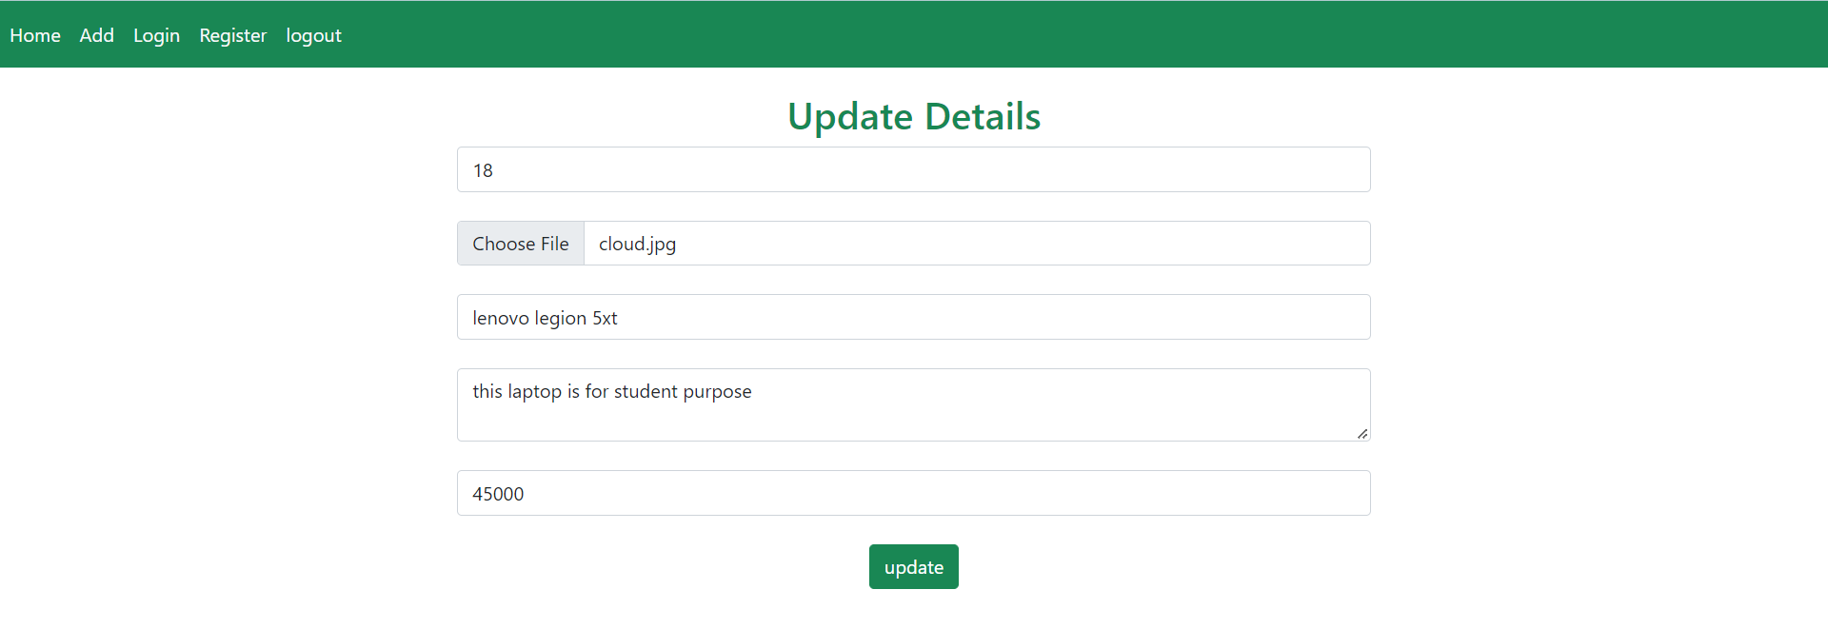

**Create.blade.php (View)**

@extends('registers.layout')

@section('content')

<div class="row">

<div class="col-lg-12 margin-tb">

<div class="pull-left">

<h2>New User Registration</h2>

</div>

<br>

<div class="pull-right">

<a class="btn btn-primary" href="{{ route('registers.index') }}">Go Back</a>

</div>

</div>

</div>

<br><br>

@if ($errors->any())

<div class="alert alert-danger">

<strong>Warning!</strong> Invalid Inputs...<br><br>

<ul>

@foreach ($errors->all() as $error)

<li>{{ $error }}</li>

@endforeach

</ul>

</div>

@endif

<br><br>

<form action="{{ route('registers.store') }}" method="POST">

@csrf

<div class="row">

<div class="col-xs-12 col-sm-12 col-md-12">

<div class="form-group">

<strong>Name:</strong>

<input type="text" name="name" class="form-control" placeholder="Your Name">

</div>

</div>

<div class="col-xs-12 col-sm-12 col-md-12">

<div class="form-group">

<strong>Email:</strong>

<input type="text" name="email" class="form-control" placeholder="Your Email">

</div>

</div>

<div class="col-xs-12 col-sm-12 col-md-12">

<div class="form-group">

<strong>Mobile:</strong>

<input type="text" name="mobile" class="form-control" placeholder="Your Mobile">

</div>

</div>

<div class="col-xs-12 col-sm-12 col-md-12">

<div class="form-group">

<strong>City:</strong>

<input type="text" name="city" class="form-control" placeholder="Your City">

</div>

</div>

<div class="col-xs-12 col-sm-12 col-md-12">

<div class="form-group">

<strong>Age:</strong>

<input type="text" name="age" class="form-control" placeholder="Your Age">

</div>

</div>

<div class="col-xs-12 col-sm-12 col-md-12 text-center">

<button type="submit" class="btn btn-primary">Register</button>

</div>

</div>

</form>

@endsection

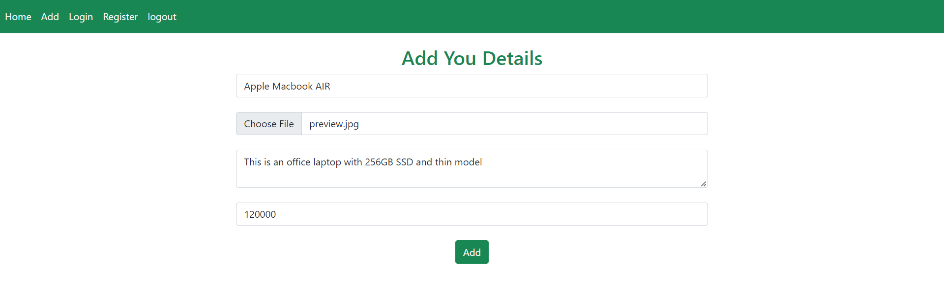

**Show.blade.php (View)**

@extends('registers.layout')

@section('content')

<div class="row">

<div class="col-lg-12 margin-tb">

<div class="pull-left">

<h2> User's Details</h2>

</div>

<br>

<div class="pull-right">

<a class="btn btn-primary" href="{{ route('registers.index') }}">Go Back</a>

</div>

</div>

</div>

<br><br>

<div class="row">

<div class="col-xs-12 col-sm-12 col-md-12">

<div class="form-group">

<strong>Name:</strong>

{{ $register->name }}

</div>

</div>

</div>

<br>

<div class="row">

<div class="col-xs-12 col-sm-12 col-md-12">

<div class="form-group">

<strong>Email:</strong>

{{ $register->email }}

</div>

</div>

</div>

<br>

<div class="row">

<div class="col-xs-12 col-sm-12 col-md-12">

<div class="form-group">

<strong>Mobile:</strong>

{{ $register->mobile }}

</div>

</div>

</div>

<br>

<div class="row">

<div class="col-xs-12 col-sm-12 col-md-12">

<div class="form-group">

<strong>City:</strong>

{{ $register->city }}

</div>

</div>

</div>

<br>

<div class="row">

<div class="col-xs-12 col-sm-12 col-md-12">

<div class="form-group">

<strong>Age:</strong>

{{ $register->age }}

</div>

</div>

</div>

@endsection

